**DAILY ASSESSMENT FORMAT**

|  |  |  |  |
| --- | --- | --- | --- |
| **Date:** | **18/05/2020** | **Name:** | **Davis S. Patel** |
| **Course:** | **Python** | **USN:** | **4AL16EC045** |
| **Topic:** | **Introduction, Small basic program and data types.** | **Semester & Section:** | **8th-A** |
| **GitHub Repository:** | **Davis** |  |  |

**AFTERNOON SESSION**

**Image of Session-**

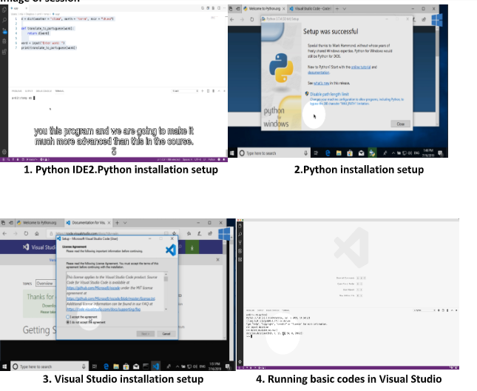

**Report –**

First, I learnt about what is, why and how simple is python. How to install Python IDE in windows.

How to install Visual Studio. How to run python code or .py files using commands.

* Python 3 and the Visual Studio Code IDE in the videos.
* A quick way to execute Python code to see how it works.
* You can make a program that shows the current date and time using these lines of code:



In the variable and data type section I learnt these many programs to find or to know how to feed

different types of data types variables in python programming.

